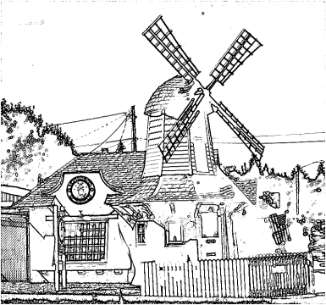

East Central Neighborhood Steering Committee/Council
Mission Statement: To Protect and Preserve the East Central Neighborhood and Its Quality of Life through Planning, Visionary Leadership, Accountability, and Neighborhood Volunteers working with City of Spokane Departments, Agencies and Neighbors for the benefit of Current and Future Residents with the Aid and Assistance of Community Development Grants and other Funding Sources.
East Central Community Center, 500 S. Stone
July 21, 2015, Tuesday Note DOT will be presenting therefore meeting will start at 6:00 p.m.

INTRODUCTIONS & ANNOUNCEMENTS Approve June 16, 2015 minutes
EXCUSED ABSENSE (Notify Joy or Heather): Excused absence____________ new members____________

- NEIGHBORHOOD BUSINESS:
- DOT North Corridor: Darrel McCalllum 6:00 to 7:00 1 hr.
- NRO Officer Dion Mason: 5 Min.
- City Council guests: 5 Min.

- COMMUNITY ASSEMBLY UPDATE:
- CA report: Joy H. 5 Min.
- PeTT Committee Meeting: Harrison B. 3 Min.
- Public Safety Meeting: Joy H. 3 Min.
- Community Development Block Grant: Valena A., Joy H. 20 Min.
- Neighborhood Clean-up Program: Jerry N. . 2 Min.

- COMMITTEE REPORTS:

- NEIGHBORHOOD REPORTS:
- COPS report: Lois D. 3 Min.
- ESBA: Sprague TIP Implementation Plan: Jim H. 3 Min.
- SRHD -Neighborhood Matters report: Jennifer H. & Debby R, (Community Café) 5 Min.
- South Perry report: Deb C. 5 Min.

OLD BUSINESS:
.

NEW BUSINESS:

Next ECNSC/C meeting: Tues Sept. 15, 2015 - 6:00 at East Central Community Center (ECCC) 500 S. Stone

Next Executive Board Meeting: Tuesday Sept. 1, 2015 - 12:00 at Wisconsin Burger 916 South Hatch Street

