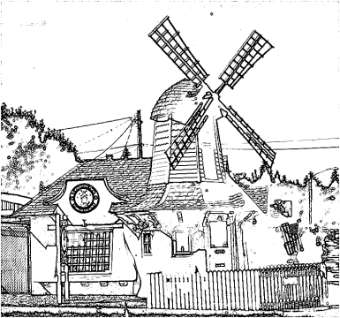

East Central Neighborhood Steering Committee/Council
Mission Statement: To Protect and Preserve the East Central Neighborhood and Its Quality of Life through Planning, Visionary Leadership, Accountability, and Neighborhood Volunteers working with City of Spokane Departments, Agencies and Neighbors for the benefit of Current and Future Residents with the Aid and Assistance of Community Development Grants and other Funding Sources. East Central Community Center, 500 S. Stone
December 15, 2015 at 6:30 p.m.

INTRODUCTIONS & ANNOUNCEMENTS Approve October 20, 2015 minutes
EXCUSED ABSENSE (Notify Joy or Heather): Excused absence ___________ new members __________
- NEIGHBORHOOD BUSINESS:
- NRO Officer Dion Mason 5 Min.
- City Council guests: 5 Min.
- Ombudsman update: Deb Conklin 3 Min.
- East Central Community Center: Carol Christnacht 3 Min.
- Nomination Committee Slate of officers: Joy H., Doug S., Heather W., Debby R. 15 Min.

- COMMUNITY ASSEMBLY UPDATE:
- CA report: Lois D. 5 Min.

- COMMITTEE REPORTS:
- Sidewalks: Doug S. 3 Min.
- Community Development Block Grant (proposed program to fund sidewalk repair): Valena A. 15 Min.
- PeTT Committee Meeting: Harrison B. 3 Min.
- Public Safety Meeting: Joy H. 3 Min.
- Social Media update: Alicia P., Karen S. 5 Min.
- NEIGHBORHOOD REPORTS:
- COPS report: Lois D. 3 Min.
- ESBA: Sprague TIP Implementation Plan: Jim H. 3 Min.
- SRHD - Neighborhood Matters and Community Café report: Jennifer H. 5 Min.
- South Perry report: Deb C. 5 Min.
OLD BUSINESS:
NEW BUSINESS:
Next Executive Board Meeting: Jan 5, 2016 - 12:00 at Wisconsin Burger 916 S Hatch St
Next ECNSC/C Meeting: Tues. Jan 19, 2016 - 6:30 at East Central Community Center (ECCC) 500 S. Stone

Neighborhood Clean-up end of year report:
Event | Date | Funds Used | Tonnage
curbside | 6/1 | $827.53 | 3.76
curbside | 6/4 | $775.05 | 2.63
curbside | 6/5 | $3,481.88 | 18.57
passes | 10/3-10/18 | $1,475.16 | 13.16
curbside | 10/19 | $741.26 | 2.30
curbside | 10/22 | $562.34 | 1.17
curbside | 10/23 | $2,592.13 | 12.35
 | TOTAL | $10,455.35 | 53.94

