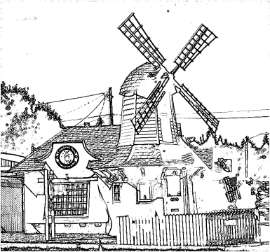

East Central Neighborhood Steering Committee/Council
Mission Statement: To Protect and Preserve the East Central Neighborhood and Its Quality of Life through Planning, Visionary Leadership, Accountability, and Neighborhood Volunteers working with City of Spokane Departments, Agencies and Neighbors for the benefit of Current and Future Residents with the Aid and Assistance of Community Development Grants and other Funding Sources.

INTRODUCTIONS & ANNOUNCEMENTS—Approve February 2016 minutes
- NEIGHBORHOOD BUSINESS:
- NRO: Officer Dion Mason
- City Council guests
- Ombudsman update: Deb Conklin
- North South Freeway: WSDOT
- Spokane Public Library: Library Future Study
- Sheridan Principal: Larry Quisano

- COMMUNITY ASSEMBLY/CA COMMITTEE UPDATES & REPORTS:
- CA report (CA Retreat): Valena
- CA/CD (CDBG): Valena
- Building Stronger Neighborhoods: Heather W
- Land Use: Max B
- Public Safety: Ron

- NEIGHBORHOOD REPORTS:
- ESBA: Jennifer H./Elysia
- SRHD - Neighborhood Matters & Community Café report: Jennifer H.
- SPBNA: Deb C.
- WSU April event: Elysia

OLD BUSINESS:
Clean up
Traffic Calming Applications

NEW BUSINESS:
By Laws: proposed changes will be voted on in April
Residential Tree Program

Next Executive Board Meeting: April 5, 2016 NOON location TBD
Next ECNSC/C Meeting: Tues. April 19, 2016 - 6:00 at East Central Community Center (ECCC) 500 S. Stone

IMPORTANT DATES TO REMEMBER:
February 25- June 7 | Clean-up Applications Open
5th Wednesday of March | Community Assembly & City Council Meetings
April 18-24 | Residential Tree Program

